
PRODUCT AND ACCESS CONTROL REFERENCE

BuildTrack Main Roles and Access Reference
  - The authoritative guide to who can see and do what in BuildTrack
This reference explains the BuildTrack project, the active role model, each role's powers and boundaries, and the screens that each persona uses. Product, design, engineering, operations, onboarding, and testing teams should use it as the starting point for access decisions.
The main rule is simple: a role never acts alone. Effective access requires an active identity, active organization membership, an enabled role, a valid scope, and any required assignment or vendor coverage. The database and transactional commands enforce the final decision even when the interface hides unavailable actions.

What BuildTrack is
BuildTrack is a mobile-responsive construction field operations and quality-management application. Internal teams, inspectors, and approved trade partners use it to record work, assign accountability, complete inspections, submit correction evidence, communicate about observations, and independently verify completion. Authorized field data can be downloaded for limited offline work and synchronized when connectivity returns.

How to use this reference
- Use the role pages to decide the minimum role and scope a person needs.
- Use the boundaries as acceptance criteria for navigation, API, database, and test behavior.
- Treat screenshots as representative product views. Actual records depend on the user's organization, scope, assignment, coverage, and current data.
Version 1.0 5 November 2026

ACCESS MODEL

How access is calculated
BuildTrack combines identity, tenant membership, role permissions, location or company scope, and record-specific eligibility. If any required layer is missing or expired, the action is denied.
Layer | What it answers | Examples
Identity | Who signed in | Supabase Auth identity and MFA level
Membership | Which tenant admits the person | Active internal or external organization membership
Role | Which capabilities are available | Org Admin, Inspector, Vendor Tradesman
Scope | Where the role applies | Organization, division, neighborhood, home, or company
Eligibility | Which records may be acted on | Assignment, inspection lead, vendor coverage, validity dates
Workflow guard | Whether this action is valid now | State transition, version check, evidence, independence

Rules that apply to every role
- Least privilege. Grant the narrowest role and scope that supports the person's job.
- Additive roles. Inspector can be combined with an internal or vendor role; permissions add, but scope and workflow guards still apply.
- Hierarchy protection. A lower-level administrator cannot remove or weaken a grant issued from a higher level.
- Independent closure. A person cannot verify their own correction, and a company member cannot verify that company's correction.
- Server authority. Navigation is permission-aware, but row-level security and command functions are the enforcement boundary.
- Offline revalidation. Queued work synchronizes only if membership, scope, versions, and workflow conditions remain valid.

ROLE CATALOG

Active roles at a glance
The shipped catalog contains eight active organization role templates and one separately provisioned platform role. Organizations may create private roles, so custom access should be reviewed against the same principles.
Role | Primary scope | Primary responsibility
Super Admin | Platform | Operate organizations, pricing, shared catalogs, and provider oversight
Org Admin | Organization | Own tenant access, structure, standards, vendors, work, quality, and audit
Divisional Admin | Division | Administer people and delivery across assigned divisions
Area Construction Manager | Neighborhood | Run local properties, vendors, inspections, repairs, and readiness
Construction Supervisor | Location | Coordinate work, inspections, correction review, and milestones
Internal contributor | Location | Report issues and complete assigned internal work
Inspector | Location or company | Perform assigned inspections and create findings
Vendor Manager | Company | Manage company users and dispatch company assignments
Vendor Tradesman | Company work | Complete assigned repairs and submit evidence

Navigation summary
Role group | Typical primary navigation
Platform | Organizations and global settings and catalogs
Tenant administrators | Work, inspections, reports, properties, plans, vendors, administration, sync
Construction Supervisor | Work, neighborhoods, inspections, reports, sync
Internal contributor | Work, neighborhoods, sync
Inspector | Work findings, inspections, sync
Vendor Manager | Work, inspections, vendor management, administration, sync
Vendor Tradesman | Work and sync

PLATFORM ROLE

Super Admin
Scope BuildTrack platform Role code separately provisioned
Operates the BuildTrack service and organization catalog without becoming a member of each customer's field workspace.
Can do onboard, suspend, and archive organizations; manage contract pricing, platform defaults, shared role templates, and master catalogs; review organization users and approved provider metadata.
Can view organization status, usage, invitations, user access, provider coverage, pricing, and platform activity.
Cannot do open tenant homes, work items, inspections, evidence, or conversations through platform privilege alone; perform tenant work without a separate tenant membership and role.
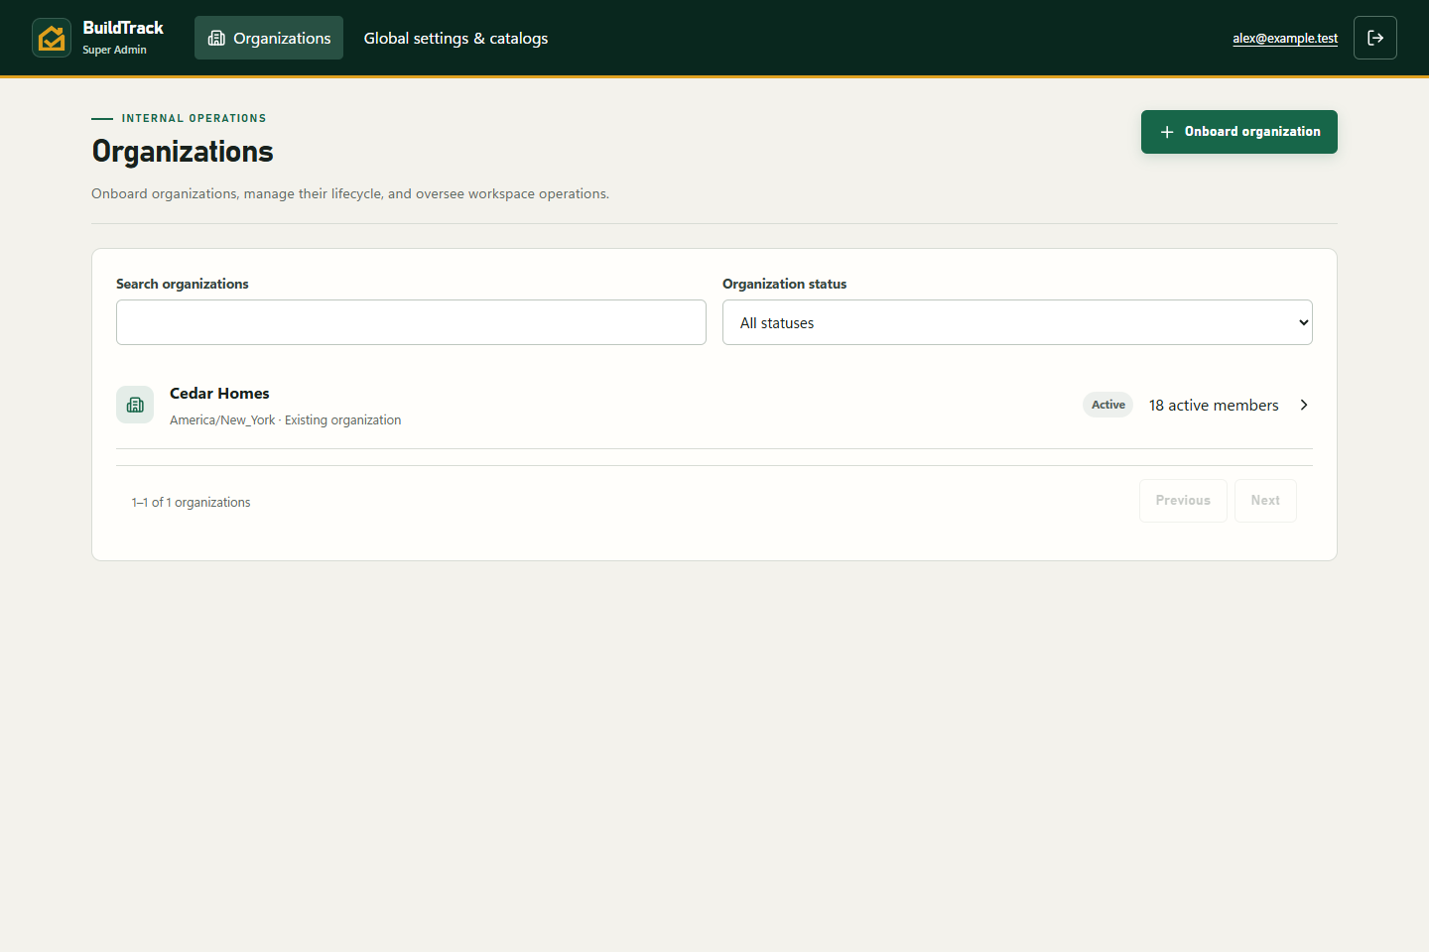
Representative screen for Super Admin. Sample records are shown; navigation and action visibility reflect this role's permissions.

ORGANIZATION ADMINISTRATION

Org Admin
Scope Entire organization Role code org_admin
Owns tenant configuration, people, structure, vendors, quality workflows, reporting, and operational continuity.
Can do manage all organization roles, users, locations, floor plans, vendors, checklists, inspections, work, reports, audit, and settings; grant scoped access and complete administrator handovers; approve milestones and independently verify eligible corrections.
Can view all authorized tenant records across every division, neighborhood, home, vendor, inspection, report, and audit trail.
Cannot do remove or suspend the last active organization administrator; verify their own correction or a same-company correction; use platform-only organization, pricing, or global catalog controls unless separately provisioned.
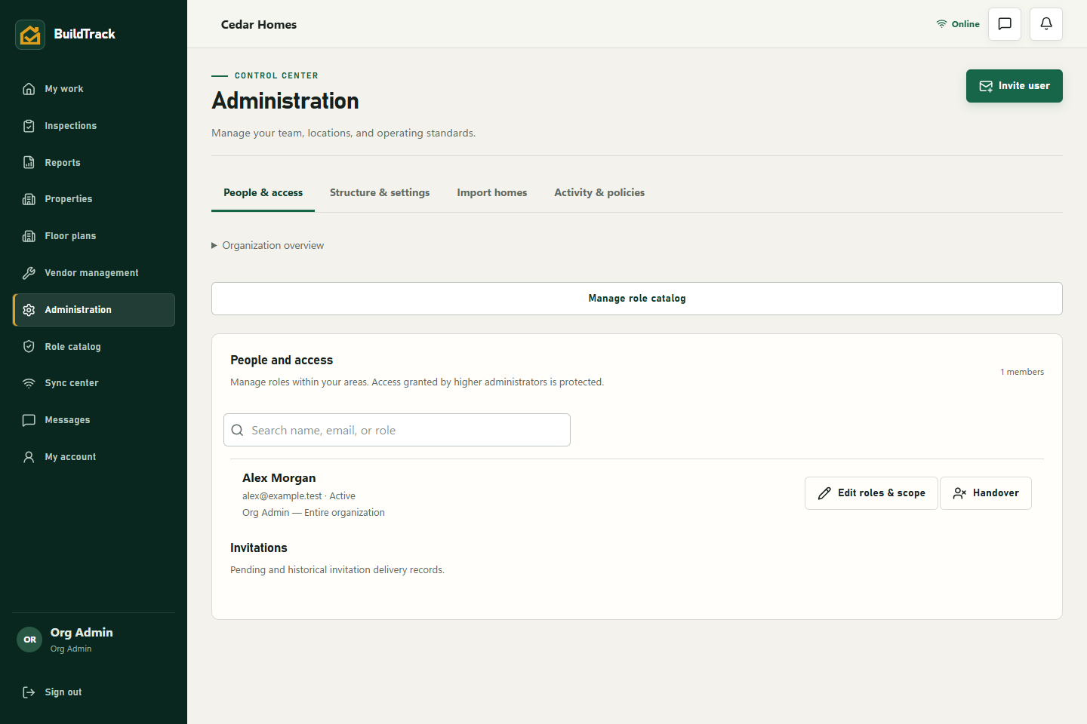
Representative screen for Org Admin. Sample records are shown; navigation and action visibility reflect this role's permissions.

LOCATION ADMINISTRATION

Divisional Admin
Scope Assigned divisions Role code division_admin
Runs people, properties, vendors, standards, and field operations inside one or more delegated divisions.
Can do create and manage neighborhoods, homes, divisional floor plans, users, roles, vendors, checklists, inspections, work, reports, and audit within scope; appoint division or neighborhood administrators within delegated authority; extend approved vendor coverage only where their authority allows.
Can view operational and administrative records in assigned divisions and their child neighborhoods and homes.
Cannot do manage another division or grant organization-wide authority; remove higher-level role or vendor coverage grants; suspend a member across the organization or change platform controls.
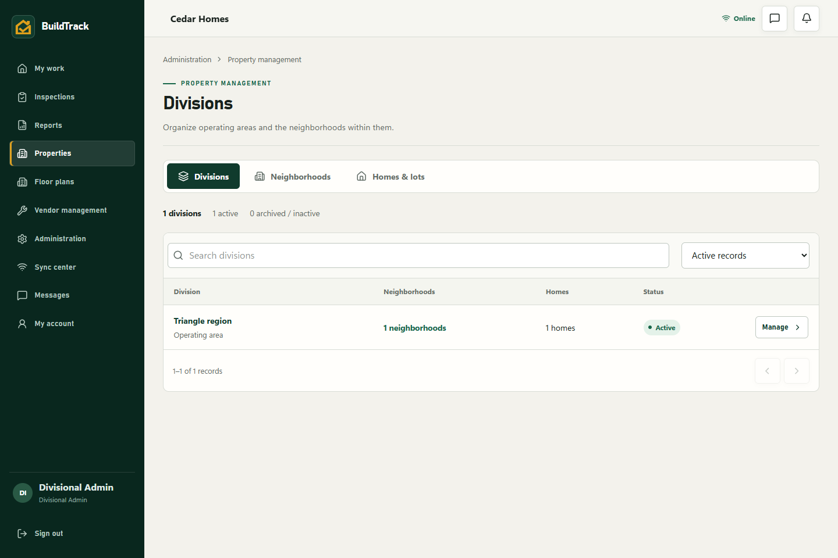
Representative screen for Divisional Admin. Sample records are shown; navigation and action visibility reflect this role's permissions.

LOCATION ADMINISTRATION

Area Construction Manager
Scope Assigned neighborhoods Role code neighborhood_admin
Administers homes, local staff, vendors, checklists, inspections, repairs, and readiness for specific neighborhoods.
Can do add and maintain lots, homes, local access, vendor eligibility, checklist configuration, inspections, assignments, repairs, reports, and milestones in scope; customize a home's copied plan and coordinate local escalations.
Can view people, homes, work, inspections, vendors, reports, and audit records for assigned neighborhoods.
Cannot do create divisions or maintain division master plans; administer another neighborhood or expand their own scope; remove parent-level access or vendor coverage grants.
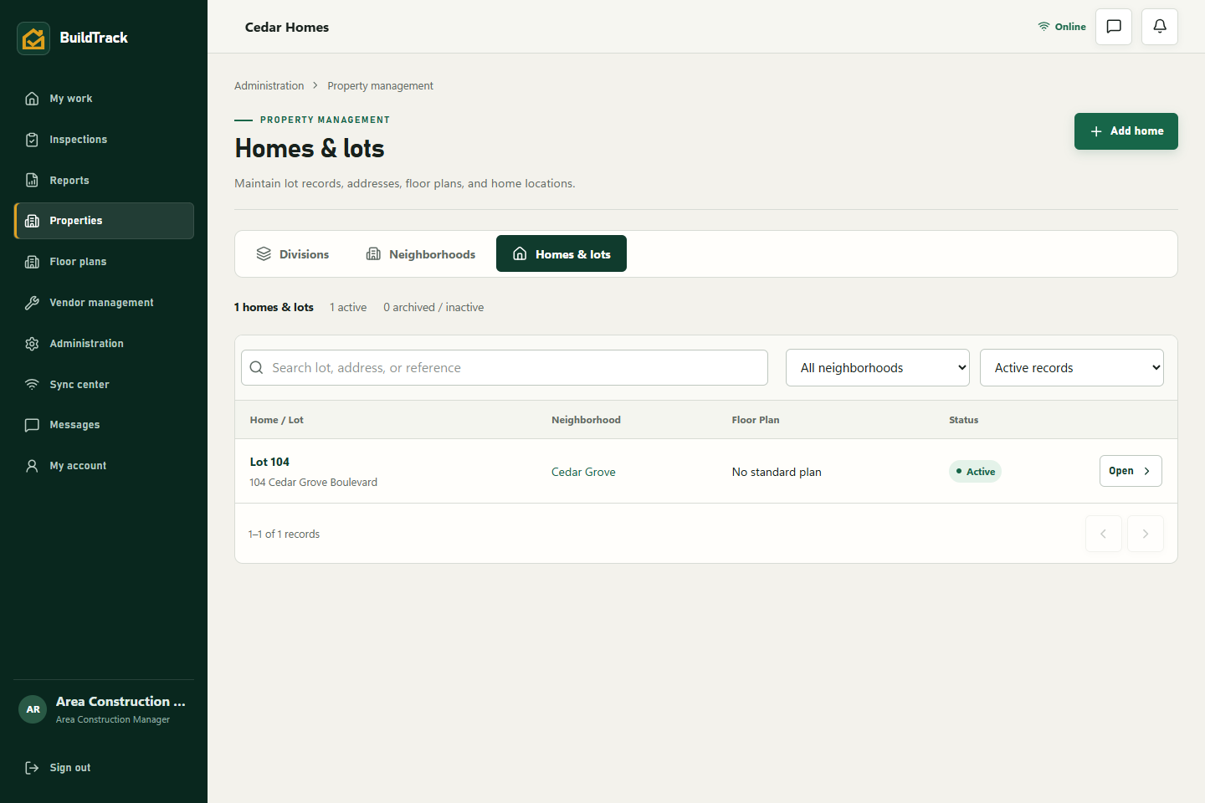
Representative screen for Area Construction Manager. Sample records are shown; navigation and action visibility reflect this role's permissions.

FIELD OPERATIONS

Construction Supervisor
Scope Assigned divisions neighborhoods or homes Role code superintendent
Coordinates daily field work, inspection scheduling, correction review, and milestone readiness without receiving people administration by default.
Can do create, triage, assign, execute, and independently verify eligible work; schedule and administer inspections; use internal and shared comments, upload evidence, read reports, and approve milestones.
Can view scoped work queues, neighborhoods, inspection status, reports, and correction evidence.
Cannot do manage users, roles, organization structure, floor plans, vendor rosters, or global settings; perform inspection checklists unless Inspector is also assigned; bypass independent-verification rules.
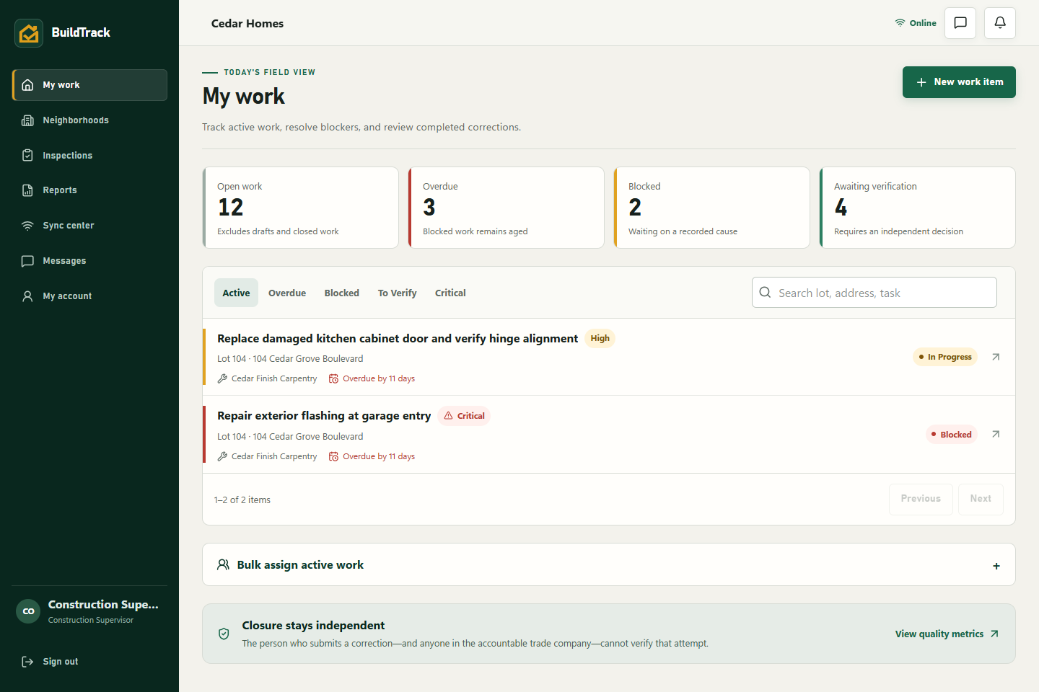
Representative screen for Construction Supervisor. Sample records are shown; navigation and action visibility reflect this role's permissions.

FIELD OPERATIONS

Internal contributor
Scope Assigned divisions neighborhoods or homes Role code internal_contributor
Reports issues and completes personally assigned internal work while keeping progress and evidence with the record.
Can do create work items; perform assigned work; post internal or shared comments and upload evidence.
Can view authorized work and home context in the assigned location scope; their sync queue and shared project messages.
Cannot do assign or verify work; schedule or perform inspections unless Inspector is added; manage users, vendors, properties, reports, role catalogs, or settings.
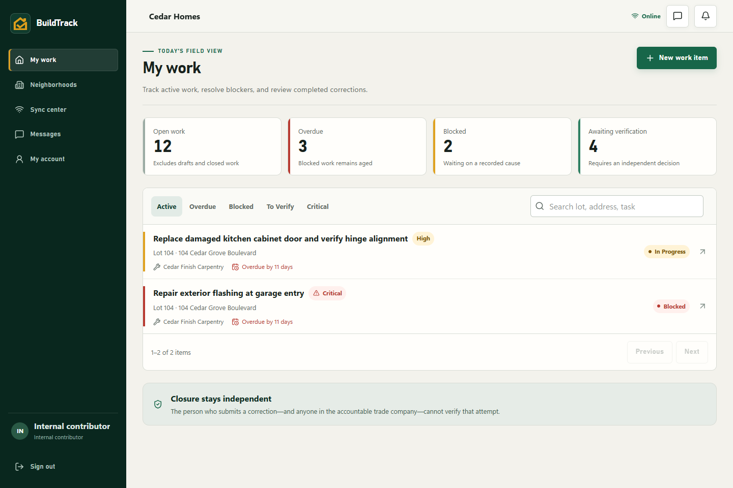
Representative screen for Internal contributor. Sample records are shown; navigation and action visibility reflect this role's permissions.

INSPECTION ROLE

Inspector
Scope Assigned locations or own company with approved coverage Role code inspector
Completes assigned inspections and records checklist findings. This role is additive for internal staff or approved company users.
Can do perform assigned inspection checklists; create findings, upload evidence, and use shared comments; complete assigned reinspections when eligible.
Can view authorized inspection records, homes, checklist items, findings, and evidence required for the assignment.
Cannot do schedule or administer inspections solely through this role; read internal-only comments; dispatch repairs, administer users or vendors, or verify corrections solely because they inspected them.
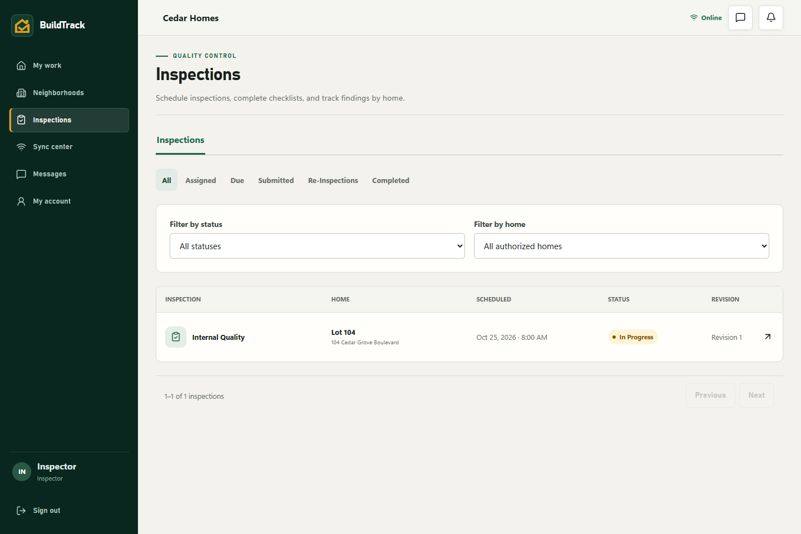
Representative screen for Inspector. Sample records are shown; navigation and action visibility reflect this role's permissions.

VENDOR COMPANY ROLE

Vendor Manager
Scope Own company and approved coverage Role code vendor_admin
Manages the vendor company's BuildTrack users and dispatches company work to eligible personnel.
Can do invite and manage company users; grant permitted company roles including Inspector; delegate company repair and inspection assignments, add shared comments, and upload evidence.
Can view the company's authorized team, approved coverage, assigned work, shared conversations, and completion status.
Cannot do administer builder employees or unrelated companies; expand or remove builder-controlled geographic coverage; read internal comments, change organization settings, or verify same-company work.
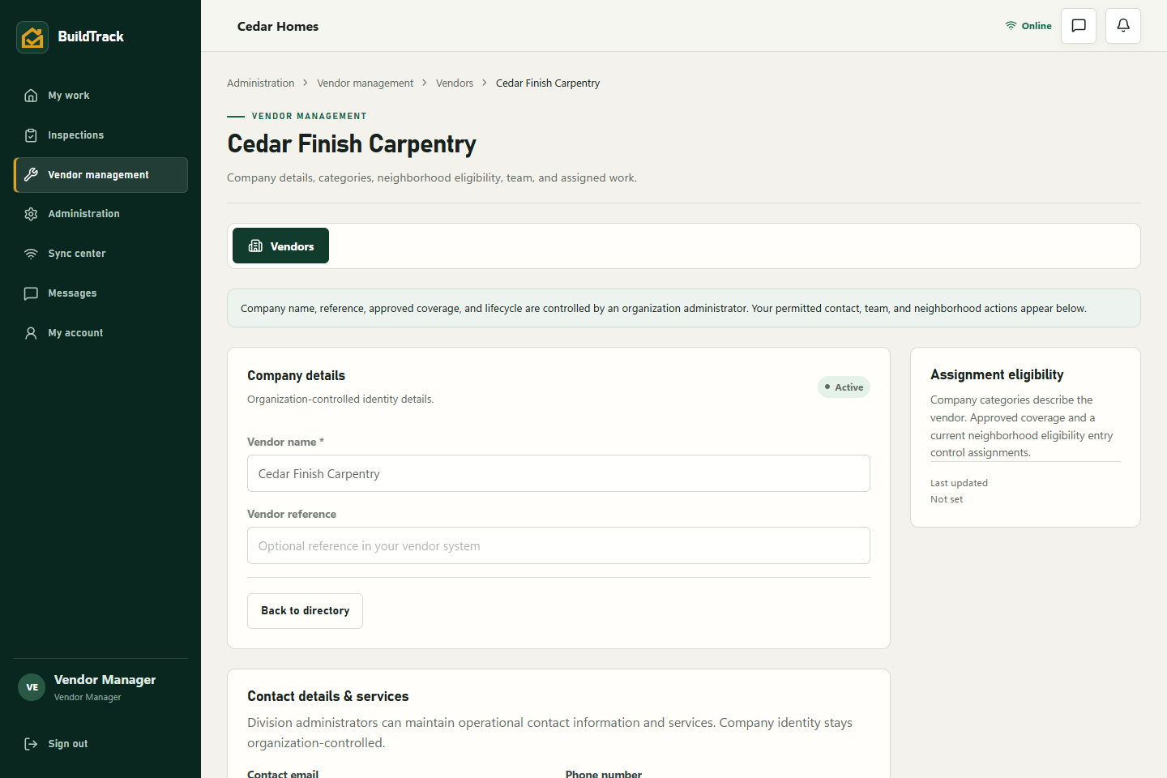
Representative screen for Vendor Manager. Sample records are shown; navigation and action visibility reflect this role's permissions.

VENDOR COMPANY ROLE

Vendor Tradesman
Scope Own company and eligible assigned work Role code trade_technician
Completes vendor repairs assigned to the person or accountable company and submits evidence for independent review.
Can do acknowledge and perform assigned repairs; report blockers; post shared comments, upload evidence, and submit corrections.
Can view eligible assignments, work details, shared conversation history, and evidence for those assignments.
Cannot do manage company users or coverage; view internal comments or unrelated company work; assign or verify work, approve milestones, or inspect unless Inspector is also assigned.
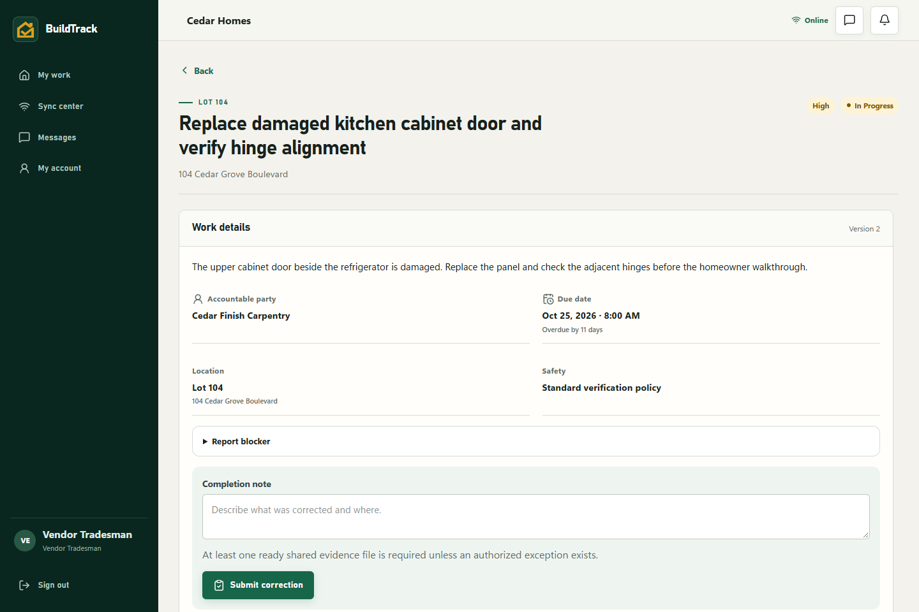
Representative screen for Vendor Tradesman. Sample records are shown; navigation and action visibility reflect this role's permissions.

GOVERNANCE

Role assignment and review
Administrators should assign roles by responsibility, then narrow them to the locations or company relationship required. Availability in the role catalog does not grant access by itself.

Onboarding sequence
- Confirm the person's organization relationship and whether the account is internal or external.
- Select the minimum role or additive role combination.
- Choose an allowed scope and confirm that the administrator can delegate it.
- For vendor users, confirm company membership and approved coverage. For inspectors, confirm the inspection assignment or engagement.
- Require MFA where the platform or administrative workflow demands it, then verify the resulting navigation and one representative action.

Periodic review
- Review active members, pending invitations, expiring grants, vendor coverage, and custom roles.
- Replace compatibility roles left from retired templates when a current role can express the same job.
- Remove local grants only through an administrator with matching authority; preserve historical work and audit records.
- Before a handover, establish and test the replacement administrator. BuildTrack prevents removal of the last active organization administrator.

Validation checklist
Control | Expected result
Navigation | Only relevant areas and actions are presented
Direct URL | Unauthorized routes do not reveal protected data
Database | Row-level security restricts reads to effective scope
Commands | Writes reject invalid state, stale versions, missing evidence, or ineligible assignees
Independence | Self and same-company verification attempts are rejected
Audit | Role, scope, administrative, and workflow changes retain actor and time
Offline | Queued changes revalidate access and conflicts before synchronization

Catalog note
Sales Rep is planned for the future.

